# The Brain Stroke Prediction

The report provides an analysis of a brain stroke dataset used generated by (Aishwarya, 2023) helped for predicting the chances of a human being getting a brain stroke rely on many other input parameters( Gender, Age, Hypertension, Heart Disease, Ever Married, Work Type, Residence Type, Average Glucose Level, BMI and Smoking status). The dataset is based on a subset of the authentic test and train dataset from Diabetes, Hypertension and Stroke Prediction (CDC, 2015), this has been received by a filtering method to perform a task of making decision tree analysis and prediction of brain strokes. All of the rows in the dataset gives important information about an patients, in the column to gives Gender, Age, Hypertension, Heart Disease, BMI and Smoking status among other relevant details.

The workflow diagram:

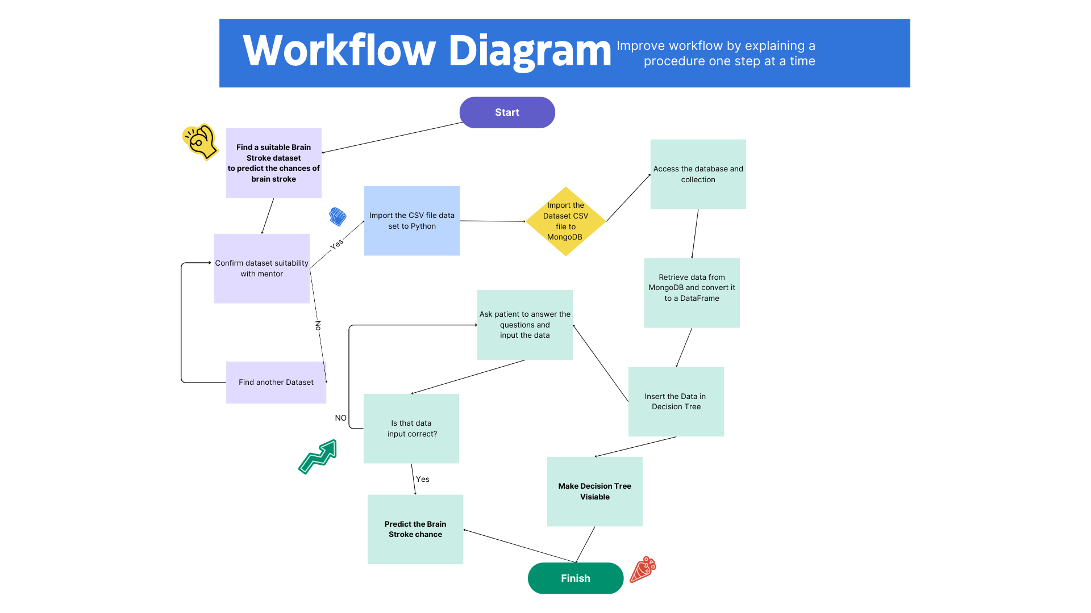

This describes the whole procedure of task done to create the Brain stroke prediction and decision tree based on stroke prediction dataset. Firstly found the dataset which accurately predicts the possibility of brain stroke occurrence chances. The dataset had to be confirmed by the mentor of project. If mentor decline the dataset module we move to look for another dataset. Finally after approval we move to import the dataset into python then import the same dataset to Mongo DB. From Mongo DB platform we access the dataset and collection created then retrieve the dataset after this we converted this into a data frame which can be understood by Python. Throw this data frame we make decision tree and go for another task of predicting the patient likeliness of getting brain stroke ten we ask the patient for input parameters like (Gender, Age, Hypertension, Heart Disease, Ever Married, Work Type, Residence Type, Average Glucose Level, BMI and Smoking status) based on these parameter we predicted the chances of stroke. Additionally if there is any error in putting the value we ask the patient to input the values again.

## What is Brain Stroke?

The brain stroke is severe condition of brain and it is known as a cerebrovascular insult (CVI) or cerebrovascular accident (CVA). In this medical condition there is an imbalance in the blood supply to the human brain. This sudden imbalance can occur from different causes, results to a range of effects for the affected human being. The history of “Stroke Association United Kingdom”, every 5 children out of 100,000 are affected by stroke in the year 2012 (Vamsi Bandi, 10 December 2020)

The strokes are a very important public health concern, with potentially severe implications for human beings. This report aims to explore the parameter and the important associated with the stroke, majorly concentrated on age, gender, hypertension, smoking status and other factors. This report provides insights from a larger dataset majorly selected for decision tree analysis and the prediction of brain strokes.

## Reasons of Brain Stroke

The stroke can caused by multiple factors that includes:

Age: Age and brain stroke has the highest correlation because with age human being tend to be more at risk of diseases and blood pressure. This affects the brain stroke predictability.

Gender: Men and women has different set of brain stroke factors that is why it is important to take into account this factor for brain stroke prediction.

Hypertension (High Blood Pressure): This factor has significant relation with brain stroke because higher the blood pressure higher the chances of getting a brain stroke.

Smoking: This factor is also important because smoking affects the blood of human being in a very negative way so it is important to take into account this information. Smoking contributes to the hardening and narrowing of arteries.

Average Glucose Level: This factor has significant negative relation with the blood of individual because uncontrolled diabetes can damage the blood vessels of individual which results in increase stroke risk.

### Heart Disease: The risk of cardiac complications increases proportionally to the severity of ischemic stroke and neurological deficits (Zhili Chen, 2017). The heart is centre of providing blood to each nerves of the body so any imbalance in the heart can cause imbalance in brain blood supply. This means heart has direct proportion of relation with brain stroke.

Ever Married: Divorce was associated with higher risk of stroke, especially in men. Living in marriage or as unmarried or widower had only little or no impact on the risk of stroke (K. K. Andersen, 2018). This factor also plays a role in identifying the predictability of brain stroke because as per research of (K. K. Andersen, 2018) showing that divorce make a significant impact on individual’s brain.

Work type: Hectic work which involves physical and mental involvement at highest level also impacts the brain stroke of individual. Vocational rehabilitation services developed with the stroke service user in mind are scarce in the United Kingdom (Walker, 2012).

BMI: Further, it has been established that for a BMI greater than 20, an increase by every unit adds to the ischemic stroke risk by 5% (Gabriel A Quiñones-Ossa, 2021). This factor has a significant relation with the brain stroke of individual because higher the BMI means the individual has higher fat in body which cause less mobility of blood that makes high chances of brain stroke.

Brain strokes can have very important effects, affecting a human’s physical and mental functions. The implications of a brain stroke causes speech difficulties, paralysis, memory problems, and in severe cases, death. The harshness of these associations can vary dependent on the blood type, heart rate and degree of the brain impairment caused by the stroke.

## Graphical User Interface

In this dataset report with the help of Graphical user interface (GUI) model

The GUI-based application helps as an influential instrument for predicting the probability of a Individual’s facing a brain stroke by means of decision tree analysis. It is influence by informative dataset by (Aishwarya, 2023) containing a subgroup of test and train data, methodically clean to ensure detailed predictions. Users can input in this user-friendly interface by using the following parameters related with the strokes: age, gender, heart and brain diseases, smoking status and BMI.

1. Decision Tree Analysis: on the bases of dataset given through Mongo DB program launching the submission, users are presented with the button to make a Decision Tree. After clicking the 'Decision Tree' button, the program unlocks a new window, revealing a demonstrative decision tree diagram that visually signifies the difficult relation of the dataset columns. This in-built visual aid makes users in understanding the difficult factors making brain stroke prediction analysis. Here is the decision tree of whole dataset created by taking all parameters of dataset:

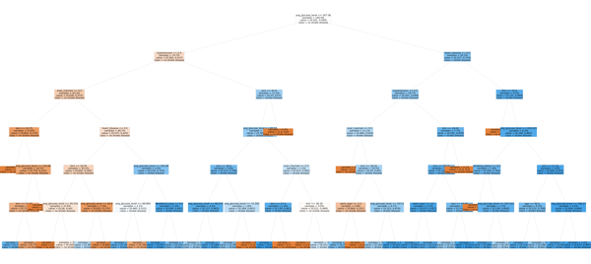

1. Prediction Using User Input: One of the unique features of this GUI is its capability to take user input for predicting brain stroke likelihoods. Once opening the main window, users are encouraged to input definite attributes that play a key role in brain stroke prediction. These attributes comprise of gender, age, hypertension, heart disease, marital status, work type, residence type, average glucose level, BMI, and smoking status.
2. Prediction Outcome: After accepting the essential attribute data, users can activate the prediction process by clicking the 'Prediction' button. The program relates advanced K-Nearest Neighbours (KNN) analysis, to calculate the provided data against the Stroke prediction dataset provided by Mongo DB. The outcome is a forecast that notifies users about their chances of experiencing a brain stroke. The result is revealed in a user-friendly pop-up window, providing clear and concise info.

*Video*

The GUI-based application allows users to discover the multidimensional background of the brain stroke prediction with the help of decision tree analysis and adapted stroke risk assessment. Its user-friendly design, predictive accuracy, and combination of outside research findings make it a valued source for both healthcare professionals and individuals looking for knowledgeable understandings interested in brain stroke risks.

## Conclusion

Conclusively, explanation delivers a summary of how users can network with GUI to forecast brain strokes risk and highlights the user-friendly design and valuable visions it provides.This blog gives important insight on the parameter related to the brain strokes, including gender, age, various diseases, and smoking status. Considering these features and their consequences is important for effective stroke avoidance and managing. Moreover, it delivers valued insights into the dataset helps aimed for predictive analysis and choice-making in the area of healthcare.

# Works Cited

Aishwarya. (2023). *Healthcare Dataset Stroke Data.* https://gist.github.com/aishwarya8615/d2107f828d3f904839cbcb7eaa85bd04.

CDC, s. (2015). *Diabetes, Hypertension and Stroke Prediction.* Retrieved from kaggle: https://www.kaggle.com/datasets/prosperchuks/health-dataset?select=stroke_data.csv

Gabriel A Quiñones-Ossa, C. L.-B.-S. (2021, Jan 4). *Obesity and Stroke: Does the Paradox Apply for Stroke?* Retrieved from The National Center for Biotechnology Information: https://www.ncbi.nlm.nih.gov/pmc/articles/PMC7946563/#:~:text=Further%2C%20it%20has%20been%20established,%25%20%5B7%2C47%5D.

K. K. Andersen, T. S. (2018, March 01). *Married, unmarried, divorced, and widowed and the risk of stroke.* Retrieved from onlinelibrary: https://onlinelibrary.wiley.com/doi/abs/10.1111/ane.12914

Vamsi Bandi, ,. D. (10 December 2020). *Prediction of Brain Stroke Severity Using Machine Learning.* Kuala Lumpur: Revue d'Intelligence Artificielle.

Walker, K. A. (2012). *Impact of Stroke on Return to Work.* Cambridgeshire: Cambridge University.

Zhili Chen, P. V. (2017, Aug 4). *Circulation Research.* Retrieved from ahajournals: https://www.ahajournals.org/doi/full/10.1161/CIRCRESAHA.117.311170